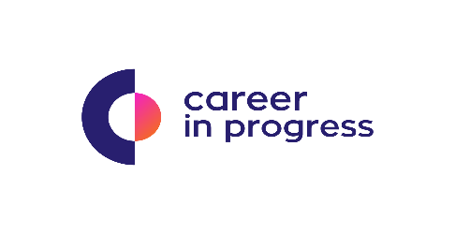
Career In Progress, is a Career Management & Recruiting Company that offers boutique services for businesses across Greece.
On behalf of our Partner, a Pharmaceutical Company based in Athens is currently seeking an experienced HR Manager to be responsible for the full scope of employee life-cycle generalist duties.
Our Client:
Serving medical science with passion, creativity and ethos & putting human life as top priority, our client is operating for more than 55 Years in the Pharmaceutical sector; becoming a thought leader by cherishing hard work & integrity.
The main responsibilities of this role will be to:
- Proactively participate in and monitor all HR activities related to benefits, compensation, staffing and employee relations - evaluating the effectiveness of current activity and implementing necessary changes
- Be heavily involved in the recruiting process; performing interview activities and assisting managers with selection
- Provide HR support throughout the employee life cycle, including initiating and monitoring onboarding, performance reviews and providing employee relations guidance
- Understand the pulse of the organization and be a source of guidance for our employees
- Design initiatives that promote positive work environment and collaborative culture
- Implement sourcing strategies that provide a qualified and diverse candidate pool through networking, referrals, job postings and direct sourcing for passive talent;
- Partner with senior management to resolve internal employee issues
Qualifications include:
- Bachelor’s degree in Human Resources or related field of study
- Minimum 5 years’ experience in HR generalist roles, specifically in a manufacturing or pharmaceutical environment
- Experience with a multi-site HR role and ability to provide direct leadership across the entire spectrum of HR service needs
- Strong knowledge of employment laws and regulations
- Must possess professional written and verbal communication, along with excellent interpersonal skills to develop relationships with management and employees
- Ability to motivate, inspire confidence, produce quality work within tight timeframes and simultaneously manage several projects.
- Proven ability to work as a team player

Benefits, Growth Opportunities & Other Information
- Benefits include: Competitive Pay Based on Experience and strong opportunity to Grow

Please send your CV strictly in English at jobs@careerinprogress.gr, quoting reference: (HR_Manager)

