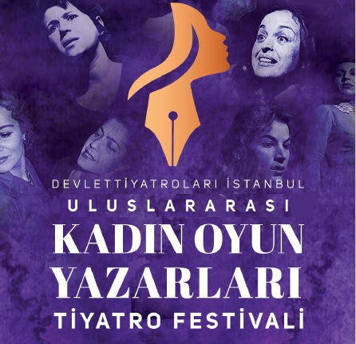
TURKISH STATE THEATRES, ISTANBUL
INTERNATIONAL WOMEN PLAYWRIGHTS THEATRE FESTIVAL
AKM & ÜSKÜDAR TEKEL STAGE, 16 - 26 NOVEMBER 2024

As the contradictions surrounding humanity deepen and grow in today's world, more impartial and more sophisticated approaches gain importance for the recognition and solution of problems. Undoubtedly, the place of women's unique sensitivity and women's point of view is very valuable in these approaches. As women, who create value by participating in economic, social and cultural life shoulder to shoulder with men, become individualized and liberated, she uses her right to criticism and discourse in the face of contradictions, making her activity in the field of theater writing even more indispensable. That's why an increasing number of women playwrights are calling out to the art of theater with their stories from the deepest parts of life, and presenting valuable works of art. To increase awareness, to keep contradictions alive and to offer suggestions…

With the "International Women Playwrights Theatre Festival", we aim to bring together distinguished stage performances of theatrical texts written only by women from all over the world. Our festival aims to shed light on the local and the universal through the viewfinder of women playwrights who have lived in different cultures, to raise awareness of conflict areas and to create a platform where solutions can be presented from a women's perspective.

We are looking forward to applications from theaters around the world that embrace plays by women writers in their repertoire.

Kind regards,
Tamer Karadağlı
General & Art Director
Turkish State Theatres

CONDITIONS of PARTICIPATION
- “International Women Playwrights Theatre Festival” will start on 16 November 2024 and will end on 26 November 2024.
- The festival will take place at Atatürk Cultural Centre (AKM) and Üsküdar Tekel Stage in Istanbul.
- Each company should send full video record, filled application form and 10 high resolution photos of the performance through online file sharing websites such as Dropbox, Google Drive etc. Applications made through the websites that impose time limitations will not be accepted.
- The application deadline is 12 August 2024.
- The group should not exceed the maximum of 20 participants (incl. actors, actresses, technical and other staff). Groups with lesser number will be preferred.
- Accommodation (bed&breakfast) will be covered by Istanbul State Theatre. For the lunch and dinner each group member will be paid an allowance of Turkish Lira equivalent of € 25 per person for each day of stay in Istanbul by Istanbul State Theatre. Please note that on the arrival day morning arrivals will be given this amount, late afternoon arrivals will be subjected to a certain stoppage in per diems.
- Each company is expected to determine and send information about the dates of arrival and departure, performance and the number of days will be spent in Istanbul. According to this information, performance date will be mutually fixed. This information should be sent immediately after the application is confirmed.
- Hotel room placement/pairing schedule should be sent immediately after the application confirmed.
- Playwrights and directors will stay in single rooms, other company members in double or triple rooms.
- Each group should send a summary of their performance/play by e-mail immediately after the application is confirmed.
- Each group is expected to bring their own national flag and the flag of their company as well as enough amounts of brochures, photos (on flash disk) and any advertisement materials regarding the groups’ performance.
- Names, passport numbers and duty of the members of participant theatre should be sent completely and correctly.
- Any damage at the hotel is in the responsibility of the participating group and will be refunded from the group or the director.

APPLICATION FORM
COMPANY INFORMATION
Company Name:
Company Web Address:
Country:
Address:
Phone:
Fax:
E-mail:
Contact Person (his/her position):
Brief Company History (Max. 200 words):

PERFORMANCE DETAILS
Performance/Play Name:
Playwright:
Director:
Brief description of the performance (Max 200 words):
Brief information about the playwright (Max 200 words):
Primary discipline:
Target age group:
Language:
Duration and number of acts:
Cast list:
List of Creative Team (names and duties):
Total number of the group:
- Does your performance have special requirements:
- Preferred dates of performance:
- Proposed venue/type of venue:
- Time required for:
- Set:
- Lights:
- Sound:
- Size of required acting area:
- Proscenium: - Backstage:
- Technical specifications, stage & lighting plans:

ADDITIONAL REMARKS:
- Please send full video record, filled application form and 10 high resolution photos of the performance through online file sharing websites such as Dropbox, Google Drive etc. to the e-mail address written below. Applications made through the websites that impose time limitations will not be accepted.
- Please do not change the format of the application form. Filled forms should be sent as Word Document.
- Please fill the form in English or Turkish.

CONTACT INFORMATION

Festival Coordinator: Mrs. Burcu Boran

Web site: www.devtiyatro.gov.tr
E-mail: istwomenplaywrightsfest@gmail.com
Tel.: +90 312 324 40 94
Address: Devlet Tiyatroları Genel Müdürlüğü 06050 Ulus Ankara /TÜRKİYE

