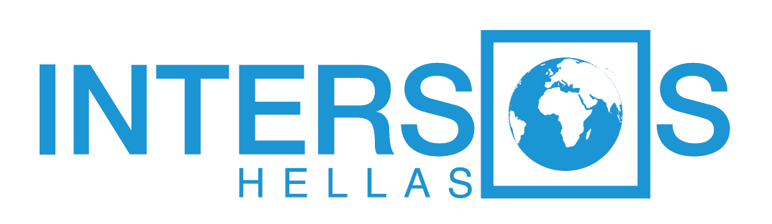

Terms of Reference
 | Job Title |  | Protection Manager
 | Country |  | Greece
 | Duty Station |  | Ioannina
 | Donor, Project Title, Code |  | UNHCR
 | Reports to |  | Protection Coordinator
Duties and tasks |  | Purpose/objective of the position:  The Protection Manager will ensure the effective implementation of INTERSOS HELLAS protection activities in Ioannina under the supervision of the Protection Coordinator, and the mainstreaming of protection issues within other program sectors. He/She is the focal point to communicate with the protection coordinator for the progress of the protection services. He/she will be also the focal point for the communication with external actors and staff in relation to the protection actions carried out. The protection manager will coordinate with the Senior Social Worker, Mediators Coordinator, Protection Officers and gather information in order to ensure the quality of the provided services and provide reports to the Protection Coordinator.  Further the Protection Manager will contribute to the development of proposals where protection programming is concerned.  He/she is expected to be honest and transparent and keep the necessary level of confidentiality on information acquired on the job.  Management and Programme Quality  Operate within a rights-based approach and ensure that all activities done are within a protection centred environment.  Ensure smooth coordination within the protection team and other actors in Ioannina.  Work with Protection Coordinator to ensure that the protection program is well documented and that the institutional memory of INTERSOS HELLAS is preserved.  Monitor the relations between staff and other protection service providers and provide feedback to the protection coordinator.  Oversee dissemination of information to protection staff.  Ensure regular and critical review of the protection strategy.  Technical manage the Social Worker Team Leader and the Mediators Coordinator in Ioannina  Monitoring and Reporting  Provide regular progress reports to Project Manager, Senior Protection Coordinator and Head of Mission as required  Provide necessary data as requested so as to facilitate external reporting in relation to the population hosted in Agia Eleni and Protection support provided.  Compile requested reports for internal and donor use  Compile weekly/monthly data reporting for donors or as often is requested.  Collect Reporting input from the Social Worker Team Leader and the Mediators Coordinator.  Finance and Administration  Comply with all established procedures for financial management  Plan the spending framework for Protection related budget and submit to the Project Manager.  Ensure the budget dedicated is spent adequately and in a timely manner  Ensure managed staff follows administration procedures.  Operate within budget lines assigned to the specific endeavour.  Human Resources and Personnel Management  Ensure the creation and maintaining of respectful and positive working relationships, which allow for the effective implementation of all activities.  Ensure reporting mechanisms are followed by the managed staff  Contribute to the selection of staff  Regularly provide feedback and review performance of staff  Ensure smooth communication is established and maintain within the team and with other supporting entities.  Ensure synergies are established and rendered functional with other teams (MHPSS, Mediation, CWC, Accommodation, Education, Health).  External Relations  Maintain relations with coordination mechanisms.  Maintain relations with relevant focal points in relation to the management of pertinent protection processes.  Maintain day to day relations with Donor in relation to Protection action  Oversee the maintaining of day to day relations with the service providers  Other  Perform other tasks and duties as required in order to ensure a correct implementation of project activities

Reporting Requirements

As per main duties outlined above the Protection Manager is responsible for

Reports to Protection Coordinator, Senior Project Manager with agreed frequency
Coordinate Weekly meetings with the relevant team leaders
Attend Internal Coordination Meetings
Log and track data storage as agreed
Provide Operational reports as necessary

As per required the Protection Manager should be copied in relation to
- General Team issues
- Coordination Issues
- Planning matters
- Human resource matters for Protection team – staff leave, absence, illness, other business.
- Protection Issues

Education, past experience and skills:
- Commitment to humanitarian principles
- Stress management skills
- Team management skills
- Native in Greek, Fluent in English both written and verbal
- Degree in Humanitarian/Social Sciences
- At least two years’ experience in a similar position

If you are really interested in the position, please send your CV in English accompanied by a Cover Letter, until Sunday 10/03/19, to: jobs@intersos.gr
Only shortlisted candidates will be informed in case of interview appointment.

