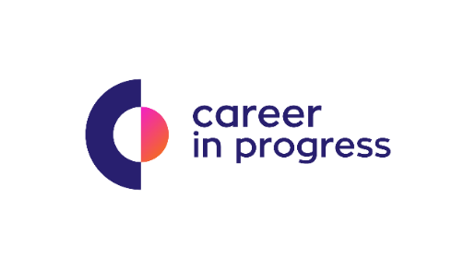
Career In Progress, is a Career Management & Recruiting Company that offers boutique services for business across Greece.

On behalf of our Partner, a Luxury Resort 4* in Protaras Cyprus, we are seeking for the season 2022 (April – October) and experienced:
Barman B
Our client:
Based in Cyprus, our client is a Luxury Resort 4*, with international standards of operation and capacity of 246 rooms. The Resort offers a rich mix of hospitality with excellent services, impeccable facilities, refined gastronomy and a wide range of options and experiences to its customers.

The main duties of this role include:
- Preparing the bar area for the service and keep it clean and tidy
- Preparing cocktails and serve all beverage in a courteous manner
- Having a sound knowledge of beverage and be able to describe the various cocktails to help guest with their order
- Helping set up and prepare functions areas
- Reporting any complaints to the Barman A in charge or Head Barman

Qualifications include:
- Previous relevant experience in 4* or 5* Hotel and/or luxury restaurant
- Good knowledge of Greek and English language. Knowledge of Russian Language will be considered as advantage
- Excellent knowledge of the Health & Safety HACCP and Food Hygiene requirements.
- Have a pleasant personality
- Teamwork, professionalism
- Obtain a health certificate and keep it valid

Benefits, Growth Opportunities & Other Information
- Attractive salary package based on experience and qualifications
- Meals and accommodation at fully equipped apartments
- Dynamic and highly professional environment

Follow this link and send your cv https://cip.gr/jobs/barman-b/

