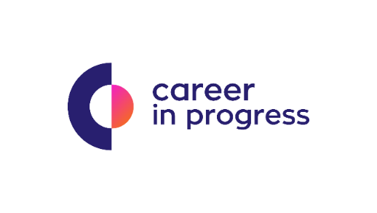

Career In Progress, is a Career Management & Recruiting Company that offers boutique services for businesses across Greece.

On behalf of our Partner, Sympraxis Team, a well-established Team of Experts based in Athens, which provides Sustainability and ESG services, we are looking for an Event and Project Management Coordinator.

The firm supports the establishment and operation of effective partnerships involving private businesses, public sector organizations and NGOs, leading to innovative and valuable contributions for the environment and society.

Sympraxis is a 360 one stop shop that provides sustainability strategy, implementation and communication services and undertakes projects for corporations such as OTE (Deutsche Telecom Group), Google, Papastratos (Philip Morris International), the European Union, the Greek state and other local and international institutions. Sympraxis currently consists of 12 team members.

The main event management responsibilities are:
- Plan Events “from start to finish”, according to client objectives and preferred setup (physical, digital or hybrid)
- Manage events (in collaboration with Sympraxis technical team) and step up to resolve problems
- Assist with tenders and bids
- Provide a solid client service experience
- Secure GDPR as well as Health & Safety procedures (Covid-19 issues included)
- Budget events and execute budget flawlessly
- Prepare thorough event reports
- Ability to travel nationally and internationally

The main project management responsibilities are:

- Plan, coordinate and execute Sustainability, CSR and Social Contribution Projects (e.g. reforestation initiatives, recycling systems, communication campaigns, e.tc.) with the support of experienced team members
- Budget projects and execute budget flawlessly
- Get involved in the production of communication materials
- Write and edit content for different communication platforms such as social media, websites, and press releases
Qualifications include:

- 7+ years hands-on work experience in Event & Project Management
- Proven experience in end to end Event Management procedures
- University Degree in Communication, Marketing, Business Administration or other related field
- Use of digital event platforms such as zoom and, webex
- Outstanding business writing skills, both in Greek and English
- Highly self-motivated, able to work autonomously, take initiative and make decisions
- Excellent multitasking while paying strict attention to details
- Excellent problem-solving skills and positive thinking
- Great interpersonal and communication skills as well as will to work in teams
- High level of integrity and ability to address partner challenges with passion
- Experience in Sustainability and CSR Project Management Procedures
- Experience in Management of Sponsorship Programmes

Nice to have:
- Driving license

Benefits, Growth Opportunities & Other Information

A competitive salary, a friendly and dynamic working environment, the opportunity to support a meaningful cause.

Follow this link and send your cv https://cip.gr/jobs/event-and-project-management-coordinator/

