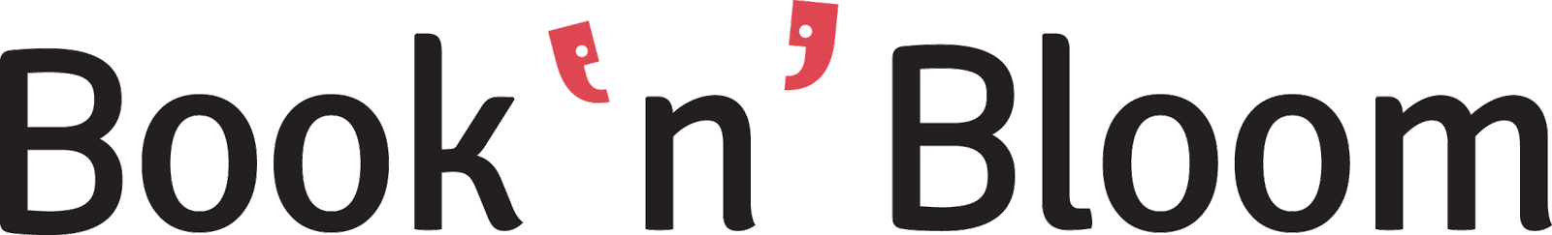

We’re looking for a passionate salesperson in Athens.
Do you like challenges? Would you like to work in a fast-paced working environment? Are you enthusiastic about innovative products? Are you a salesman to the bone and a result-driven professional?
Then you're the right candidate for our salesman position in Athens.
Role description
Researching and detecting hot leads
Daily sales meetings with potential customers
Meeting and exceeding predefined sales targets
Weekly reports on sales effort and provision of customer feedback
Update our customer acquisition internal database
Potential participation in exhibitions/seminars presenting the product
Required Skills
At least high-school graduate. A university degree would be appreciated
Minimum 2-3 years experience preferably in B2B sales
Target-oriented and comfortable to work with tight deadlines
Eligible in changing different sales techniques
Excellent communication and interpersonal skills
Fluent English speaker
Good user of Facebook
Interest in software and mobile apps
Related work experience in software products or in the beauty industry would be appreciated
We offer:
Satisfactory salary
Bonus potential based on performance
Our office is in Thessaloniki.
The vacancy is for a full-time position of 40 hours/week in Athens.
Please send us your application with CV and motivation letter in English to jobs@booknbloom.com mentioning the job title “Salesperson Athens” in the subject line.
About Book‘n’Bloom
Book’n’Bloom is a smart business tool for micro-small businesses allowing them to operate Social & Mobile. Our application is fully integrated into Facebook and offers a complete business management system including a smart reward program, customers catalogue, digital agenda with booking calendar, and notifications via SMS and Facebook.
● We are already a 3 year-old company funded for our growth and expansion and we plan to launch Book’n’Bloom in 10 new cities over the next 12 months.
● Book‘n’Bloom is about helping millions of small and great local businesses transit from pen & paper to how business is done in 2015 and give them the tools they need to meet consumers’ expectations - all neatly wrapped in one Facebook application and a FREE mobile app.
● Join us and let us help millions of small local business owners grow and stay competitive or let aspiring business owners see how fast and easy it is to get started.
For more information please visit: www.booknbloom.com

