Yes 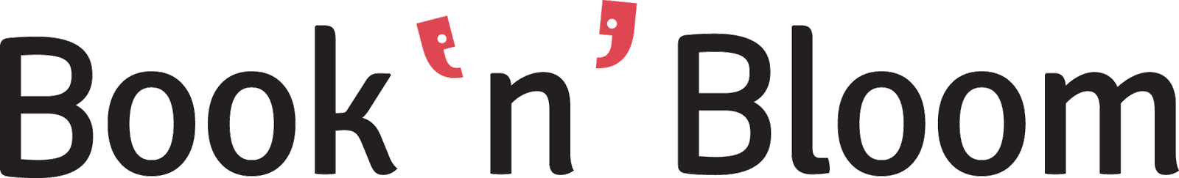

As Backend Developer you will be responsible for extending our platform according to current and upcoming business needs. You will work together closely with our team and take responsibility to deliver scalable, future proof solutions. You will work on a project, based on a number of web technologies.
As a developer you will need to have a keen eye for detail and care for systems' security. There will be a training period during which you will learn how the systems and technologies employed function together as a whole.
What is required:
- Excellent use of PHP (OOP)
- Good use of Databases (MongoDB, MySql)
- Good use of Source Version Control Systems (Git)
- Experience in using JSON
- Good understanding of REST web services
- Experience in payment platforms
- Good use of Operating Systems (*nix)
- Good use of Integrated Development Environment (Netbeans, Eclipse)
What is desired:
- Knowledge of JavaScript, JQuery
- Robust beer and caffeine consumption!
What will you gain:
- Full time salary (Full time salary for the first 2 months salary according to an annual basis of 9800 €, after the 2nd month salary raise according to skills)
- Full coverage health insurance
- Free lunch every day, access to caffeine and beer and much more ...
Our office is based in Thessaloniki, Greece. The vacancy is for a full-time position (i.e. 40 hours / week) which will be available as of July 2015.
Please send us your application to jobs@booknbloom.com by mentioning the job title "Back-End Developer" in the subject line and attaching your CV and letter of motivation.
About Book‘n’Bloom
● Book’n’Bloom is a smart business tool for micro-small businesses allowing them to operate Social & Mobile. Our application is fully integrated into Facebook and offers a complete business management system including a smart reward program, customers catalogue, digital agenda with booking calendar, and notifications via SMS and Facebook.
● We are already a 3 year-old company funded for our growth and expansion and we plan to launch Book’n’Bloom in 10 new cities over the next 12 months.
● Book‘n’Bloom is about helping millions of small and great local businesses transit from pen & paper to how business is done in 2015 and give them the tools they need to meet consumers’ expectations - all neatly wrapped in one Facebook application and a FREE mobile app.
● Join us and let us help millions of small local business owners grow and stay competitive or let aspiring business owners see how fast and easy it is to get started.
For more information please visit: www.booknbloom.com

