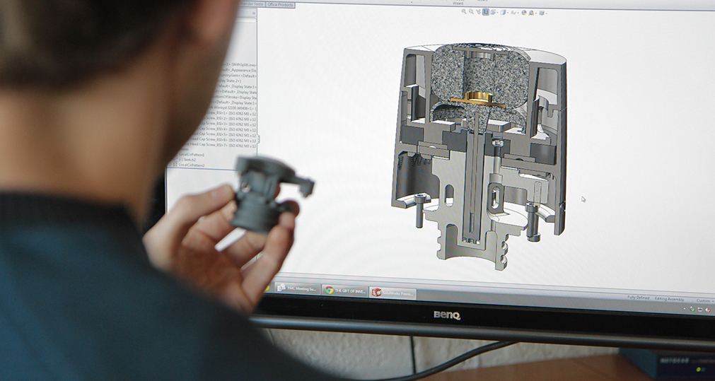

Product Design Engineers (Ref: PDEs 06/16)
Our client, a multinational company, producing personal care consumer goods, leaders in their fields, is looking for Senior Product Design Engineers, for its R&D Department in Attiki, Greece.
The Position:
The role of the incumbents will be to researching & developing ideas and processes for new products. They will be performing product engineering development and product engineering support activities. Candidates might focus on modelling with skills in research and creativity, being ingenious and detail-oriented or prototyping, with emphasis to communication and able to handle external suppliers.
The incumbents will propose innovative engineering design solutions and best practices.
The function requires working in harmony in a team environment internally and with other departments such as Testing, Machine Shop, Quality Assurance, Materials, Process Development and Production and external customers and suppliers.
Role Requirements:
Candidates must possess a mechanical engineering degree and five years’ experience on product design activities. A post graduate degree will be positively evaluated.
They should have excellent technical skills and prior experience in product design, understand R&D stages, production technologies and interactions. They should be creative and innovative, love research and detail, be supportive, accurate and precise, and dispose high levels of insistence and patience.
They should have professional skills with CAD (most preferably Creo3 and/or Pro/engineer).
Experience in plastics and product development of consumer goods will be considered as plus.
Candidates must also have project management experience, in order to plan, track, execute and follow-up project tasks.
They should speak and write English fluently and probably a second European language – ideally German.

Remuneration:
The company offers a very competitive salary bonus on specific targets and KPIs and other benefits, an excellent working environment with substantial career prospects and advancement opportunities.
If you find the position interesting, please send your CV to cv@futuretrend.gr, stating the position Ref: PDEs 06/16

