Senior JAVA Developer / Analyst
Xanthi, East Macedonia and Thrace, Greece (SJDA/11/18)

DESCRIPTION
EUROPEAN DYNAMICS has a vacancy for a highly motivated Senior JAVA Developer who is eager to work on complex and demanding projects, based in Xanthi, Greece. The successful candidate will join a highly professional team of Full Stack Java developers / Software Engineers that uses state-of-the-art technologies (Java EE multi-tier architecture) to implement challenging IT software projects, for major international public organizations.
Main responsibilities and Tasks
- Analyze, design, develop and maintain large and complex web-based Java applications within a team adhering to highly professional standards and methods;
- Ensure the delivery of quality software according to system specifications, quality requirements and company standards;
- Contribute to the overall project and system documentation and develop technical documentation;
- Support business development by analyzing customer requirements providing effort estimations and designing solution concepts - both in house and on site by international customers;
- Mentor and coach junior developers and undertake a leading role in the evolution of development process and methods by putting forward innovative ideas.

REQUIREMENTS

Qualifications and experience:
- Bachelor’s Degree in computer science, software engineering or related technical field or equivalent work experience;
- Minimum 2 years of experience with full development lifecycle in a Web environment using J2EE technologies;
- Minimum 1 year of development experience using JavaScript, AngularJS, CSS, REST, JSON and Web Sockets is an asset;
- Solid understanding of data structures, algorithms, object-oriented design and design patterns;
- Excellent knowledge of Relational Databases, SQL and ORM technologies (JPA2, Hibernate);
- Fluency in English;
- German knowledge is a plus.

BENEFITS
Our Offer:
We offer a competitive remuneration (either on contract basis or remuneration with full benefits package) based on qualifications and experience, including:
- Competitive full-time salary;
- Top - of - the line tools, language courses, specialized trainings;
- A great opportunity to grow and work with innovative and exciting specialists in the industry;
- Being part of an environment that offers challenging goals, autonomy and mentoring, which creates development opportunities, both for you and the company.
If you want an exciting challenge and enjoy collaborating with a diversity of people, then join us! Send us your detailed CV in English, quoting reference: (SJDA/11/18) to this link.
EUROPEAN DYNAMICS (www.eurodyn.com) is a leading Software, Information and Communication Technologies company, operating internationally (Athens, Brussels, Luxembourg, Copenhagen, Berlin, Berne, Stockholm, London, Helsinki, etc.). The company employs over 600 engineers and IT experts. We design and develop software applications using state-of-the-art technology. Our current ICT projects have a value exceeding 250 million EURO. EUROPEAN DYNAMICS is a renowned supplier of IT services to European Union Institutions, international organizations, European Agencies and national government administrations internationally.
As part of our dedication to the diversity of our workforce, we are committed to Equal Employment Opportunity without regard for race, colour, national origin, ethnicity, gender, disability, sexual orientation, gender identity, or religion.
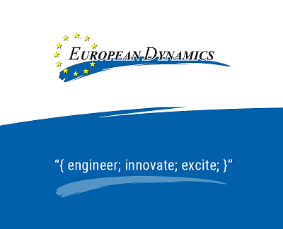

EUROPEAN DYNAMICS (ED) adheres to the General Data Protection Regulation principles by applying its Privacy Policy as published in www.eurodyn.com/privacy. By sharing your personal data with ED, you acknowledge and accept its Policy and authorise ED to assess your candidature and communicate with you in relation to the job opening.
Furthermore, when providing your data, it is up to you to explicitly consent that your data can be assessed for future job openings, for as long as you do not withdraw such consent. If you do not consent, we will not be able to consider the data you provide to us for future job openings.

