MOOCyouth: Erasmus+ Youth in detail through online course
MOOCyouth or Massive Open Online Course on Erasmus+ funding opportunities comes back for the 4th edition from 16th October to 20th November. This course will give a chance to engage into interesting, useful and fun activity and it is completely online. You can stay at home or at work and learn with a group of like-minded people. It can also become a different lecture or lesson that complement traditional curricula.
The MOOCyouth is created for youth workers, youth leaders, those working with young people, members of informal group of young people from Europe and the whole world. It will be useful if you have heard about Erasmus+ but you don’t know so much about it, you have already applied within Erasmus+ but haven’t been lucky or you would like to learn more about European youth cooperation but don’t know how to start.
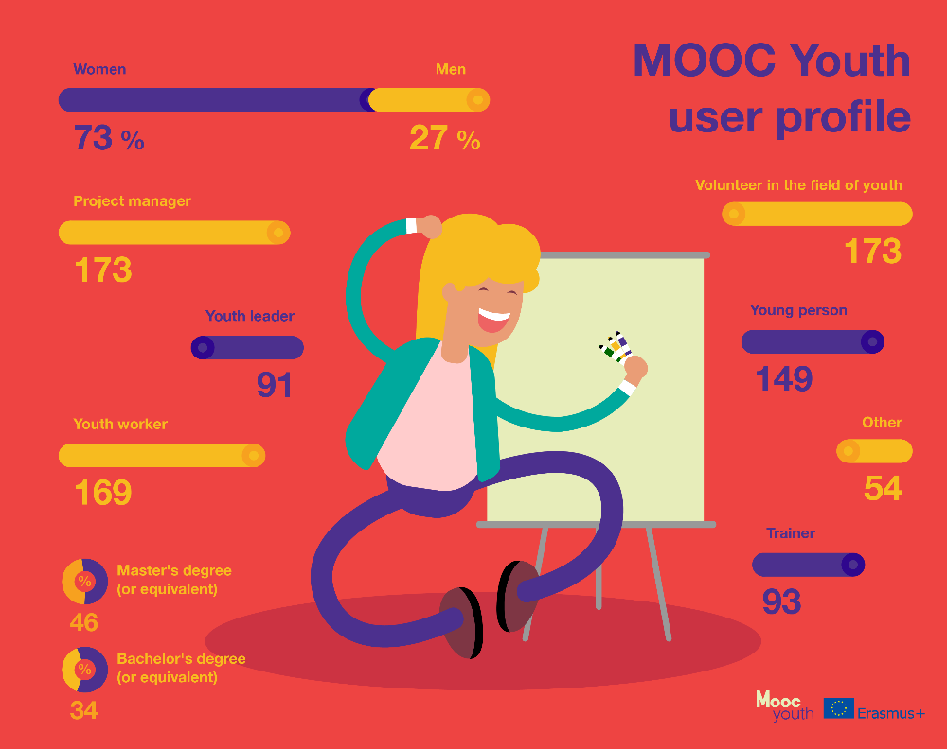
„This is such a great opportunity to learn about Erasmus+ it can change your life and anyone’s who is interested. I like how this program is attracting youth from all over the world.“

This MOOC will equip you with the basic knowledge and understanding how to use various funding opportunities and fulfil the funding requirements for international youth exchanges, European Voluntary Service, mobility of youth workers, and Structured Dialogue projects (KA3).

„This course could help not only for Erasmus+ Youth programme. It provided some good information for project management in other fields. With basic and specific information, it helps all open-minded people to use those facts in applications for jobs, projects etc. I enjoyed to be a part of it.“
You can reach the course and learn when you have time. You can pause, fast forward or rewind if you need. Moreover, you will become a member of great online community of learners. You will get a support from facilitators, experts and course mates.
Previous MOOCs gathered more than 10 000 participants from Europe and its neighbouring countries.
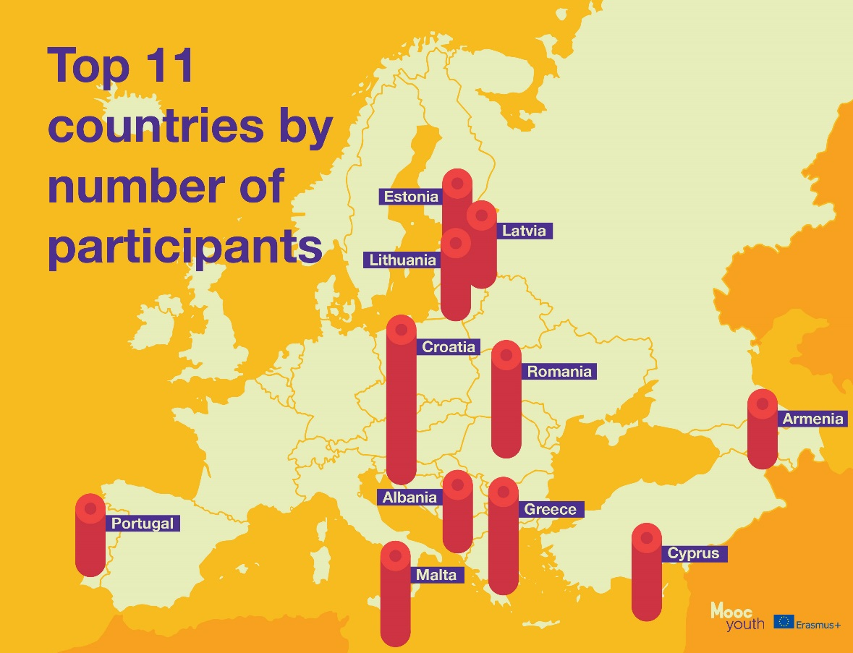
The course starts on 16th October 2017 but you can still enrol until 10th of November to get the full impression on the contents of the course.
We invite you to register here: https://www.canvas.net/browse/salto/courses/erasmus-funding-opportunities
Follow us on Facebook: https://www.facebook.com/moocyouth/
The MOOC Youth started in 2014 by SALTO Participation and was supported by several National Agencies of Erasmus+. In 2017, Agency of International Youth Cooperation is the main coordinator of the course in cooperation with National Agencies of Erasmus+ Youth from Croatia, Estonia, Germany, Hungary, Italy, Liechtenstein and Spain.
Agency of International Youth Cooperation is the National Agency of Erasmus+ Youth in Vilnius, Lithuania. From 1999 our mission is to ensure that young people and those working with them would have the opportunity to participate in European programmes for youth mobility.

