We have all heard the saying "You are what you eat". The choices we make about what we put into our bodies affect not just our waistline and health, but also our brain, behaviour, mood and even mental diseases. It is well known that overeating and an unbalanced diet increase the risk of diabetes, cardiovascular diseases, cancer and death, but evidence is available which shows that people who eat an overall healthy diet –including lots of fresh, unprocessed and nutrient-dense foods – are more likely to have better mental health compared to those that have a hypercaloric diet high in sugar and fat. Scientists all agree that the perfect diet for our health is our Mediterranean diet.
The Mediterranean is the unity of many cultures and peoples, yet it is a region that has many common factors in the culinary traditions and use of ingredients. Each nation had developed its own way of preparing and consuming food depending on the environment and the necessities of the people and time.

The Mediterranean Cuisine is based on vibrant colours of fresh vegetables and fruits, strong tastes, aromatic perfumes of herbs, sheep and goats’ cheese and fish.
Certain items, such as olive oil, bread, wine, roast lamb or mutton, bottarga and stews of meat with vegetables and tomato are indeed found all around the Mediterranean.
Although there are many different "Mediterranean diets" among different countries and populations of the Mediterranean basin, because of ethnical, cultural, economic and religious diversities, the distinct Mediterranean cuisines generally include the same key components, in addition to regular physical activity. Some of the most common ingredients are; extra virgin olive oil (as the principal source of fat), vegetables (including leafy green vegetables), fresh fruits (consumed as desserts or snacks), cereals (mostly wholegrains), nuts and legumes. Consumed more moderately are fish, seafood, poultry, dairy and red wine and a low intake of eggs, red meat, processed meat and sweets.

Diets high in refined sugars are harmful to the brain as they promote inflammation and oxidative stress. Multiple studies have demonstrated a correlation between a diet high in refined sugars and impaired brain function — and even a deterioration in symptoms of mood disorders, like depression. In particular, research suggests depression and dementia are affected by the quality of our diets throughout our lives. It is clearly important therefore, to try to understand the reasons why people, despite this common knowledge, maintain these eating habits. Our brain still works in the same way as that of our ancestors; considering sweet food as a signal for energy and calories and bitter food (like vegetables) as a warning signs of potentially poisonous plants. However, these inborn taste inclinations are not immutable and could be rewired to suit modern dietary habits. Indeed, childhood preference for high salt and sugar decreases with age, and it can also decrease in adults through repeated exposure to less salty food. Individuals can be retrained to like less fatty foods too. Sweet and bitter preferences are harder to shift, but given more research and implementation beyond the test kitchens success may be within reach. In understanding these processes neuroscience may finally provide a nutritional intervention that works. One day we will crave broccoli more than Nutella! Nevertheless, vegetarian/vegan diet is not the perfect diet for our brain but the reach and balanced Mediterranean diet is, followed by diets from Japan and Scandinavia. These diets all feature fish, one of the best sources of omega-3 fatty acids—nutrients that play a vital role in promoting neuronal health and that may have helped drive the evolution of the human brain. As an extra benefit, the Mediterranean diet adds to fish, fruits, vegetables, nuts, whole grains, lean meats in moderation, olive oil and maybe a little red wine.
Nevertheless, as World Health Organization has flagged the ever increasing rate of pesticides and the over use of chemicals in agriculture or heavy metals in the see accumulating in fish has become a risk for our health and a concern to identify.
Therefore, it is of priority importance to control if the food on sale is clean food free from harmful substances which might harm the public in general. Striving to educate both growers as well the consumer in how and what can be done to eliminate or reduce health risks and what type of ingredients to prefer is high on the agenda of many professionals.

If you wish to know more about the effects of the Mediterranean diet on one’s health you are invited to join this 3 day programme between the 10th and the 13th October.
All participants attending this short-course programme will be able to gather more information regarding the relationship between food and health and how one’s choices can lead to better health and a longer life. Experts in the field of Medicine and talented Chefs will be present to give out talks regarding the matter.
This 3 day short programme will consist of short talks during the first 2 days regarding the effects of food on the brain and heart together with a cookery session with the Master Chefs students on the 3rd day.
At the end of the course, the participants will also have the opportunity to join a day-trip to Sicily to visit organic fields, where lunch will be served on location.
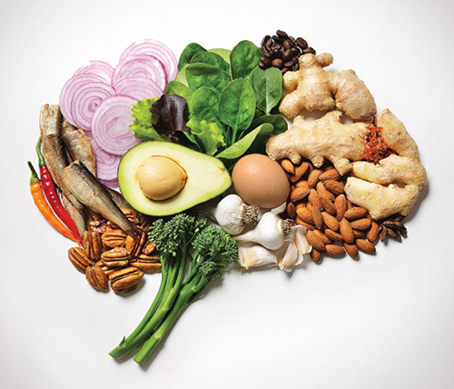

CREDIT: DAVID MALAN Getty Images

